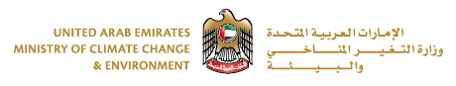

**Request for proposal**

**Design, Build, Operate, Maintain and Transfer of (Emirates Manjam) Waste Collection Centres in Residential Areas and Neighbourhoods**

|  |  |
| --- | --- |
| **Table of content** | |
| **Subjects** | **Page** |
| **1.Introduction** | **2** |
| **2.Objective** | **3** |
| **3.Project purpose** | **3** |
| **4.Project scope**  **4.1. Quantity**  **4.2. Proposed location**  **4.3. Design of facility (Emirate’s Manjam)**  **4.4.** **Operations**  **4.5.** **Historical data of waste**  **4.6. Responsibility/obligation of the Parties**  **4.7. Reporting** | **4,5,6** |
| **5.Project Proposed Time Schedule** | **7** |
| **6.Emirates Manjam’s Identity** | **7** |
| **7.Evaluation criteria** | **7** |
| **8.Deliverables (Content of the proposals)** | **8** |
| **9.Agreement** | **8** |
| **10.Intellectual property** | **8** |
| **11.Communication** | **8** |
| **Annex 1: the proposed land ) Aljerf industrial area(** | **9** |
| **Annex2: Facility design** | **10** |
| **Annex 3: (the process moving the waste from the household to Waste collection Center)** | **11** |



**Request for proposal**

**Design, Build, Operate, Maintain and Transfer of (Emirates Manjam) Waste Collection Centres in Residential Areas and Neighbourhoods**

1. **Introduction**

UAE Vision 2021 was launched by H.H. Sheikh Mohammed Bin Rashid Al Maktoum, Vice-President and Prime Minister of the UAE and Ruler of Dubai, at the closing of a Cabinet meeting in 2010 (Innovation Lab) . The Vision aims to make the UAE among the best countries in the world by the Golden Jubilee of the Union. A key goal is to ensure sustainable development while preserving the environment and achieve a perfect balance between economic and social development. To guide and measure the progress a number of National Key Performance Indicators, a number of targets have been established. One of these targets is to divert 75% of Municipal Solid Waste (MSW) from landfill by 2021..

Globally, in most countries especially in developing countries solid waste management has become a challenge. According to the World Report of June (2012) solid waste is a silent problem that is growing daily.

Waste generation increases with population expansion and economic development.

Improperly managed solid waste poses a risk to human health and the environment.

Moreover, uncontrolled dumping and improper waste handling causes a variety of problems. Integrated Solid Waste Management program (ISWM) is a comprehensive waste prevention, recycling, composting, and disposal program. An effective ISWM system considers how to prevent, recycle, and manage solid waste in ways that most effectively protect human health and the environment. ISWM involves evaluating local needs and conditions, and then selecting and combining the most appropriate waste management activities for those conditions. The major ISWM activities are waste prevention, recycling and composting, and combustion and disposal in properly designed, constructed, and managed landfills.

All developing countries are sorting and separating the waste in order to obtain environmental and Economical values of waste. And from the best practice in the world, we plan to apply this idea of separation and segregation of the waste from the sources by the society and a facility of collection will be established under the brand “Emirate’s Manjam” referred to as (EM).

This initiative will help us to improve and support our national target by adopting the 3R's concept of waste management (Reduce, Reuse, and Recycle).

Waste separation is essential for waste to be managed in a more efficient and sustainable manner. One of the outputs of government innovation Laboratory is this initiative which aims to promote individuals in the society to separate the waste from the source and reduce waste production based on the idea of developing centers within communities and residential areas to collect segregate and separate waste for the purpose of recycling under the brand of Emirate’s Manjam (EM). The centers will be first of their kind in the region which will promote changes in the mind-set of the society in areas such as waste reduction, waste separation from source, and waste recycling from disposal.

Initially, The Ministry of Climate Change & Environment (MOCCAE) has received the approval for implementing eleven Waste Collection Centers in residential areas and neighbourhoods’ initiative in the emirates of Sharjah, Ajman, Umm Al Qwain (UAQ), Ras Al Khaimah (RAK), and Fujairah. As a pilot phase, one site in Ajman (Aljerf industrial area 3-Annex 1) has been selected as profit of concept. After that we will continue with other Emirates by partnering with Globally Company.

1. **Objective:**

* Allow the community to segregation their waste and the town planning to have an integrated robust facility of segregate and treating waste in a safe and healthy manner. For the UAE to be a sustainable country, adopting the highest standards of health, safety and environment are used in line with the developed world.
* Obtain the Economical value of waste.
* To raise the level of awareness of the community on the separation and segregation of waste.
* Reduce the amount of waste diverted to the landfill.

1. **Project purpose**

The purpose of this entrepreneur idea is to develop a prototype of the idea of Emirates Manjam that will allow the society to transfer its waste in a safe manner. This facility will make sure to utilize waste in recycling and transformative method introducing by–products. The society will benefit from having those short distance, multiple and safe facilities to dispose waste without affecting the atheistic of the town thus promoting social happiness.

1. **Project scope**

**4.1. Quantity**

The current annual generation of the Municipal Solid Waste from Ajman’s emirate is around (250 thousand tons). The facility shall not receive the full waste quantity mentioned above however the figure is an indicative that shall be utilized by the bidder once preparing the proposal. The local authority has accepted the Emirate’s Manjam to receive the following waste composition delivered voluntarily by the society.

**Type of Waste:**

1. Glass and Metal containers, dry batteries, plastic, tires and Paper ,Dry batteries, lights
2. Emirate’s Manjam can also receive: Bulky waste, WEEE, woods and green wastes

**4.2. Proposed location**

Initially, The Ministry of Climate Change & Environment (MOCCAE) has received the approval for developing One Waste Collection Center in the emirate of Ajman (Aljerf industrial area 3) see Annex 1.

**4.3. Design of facility (Emirate’s Manjam)**

The site shall be designed in an easy and simple way that will allow easy entry through the main gate and move to the specific (container/bin) of each type of waste and placing it in the (container/bin) as shown in (Annex 2).

The (EM) consists of the following components: fence, gate, control room for the security, large containers and there must be signs to show each container and the specific waste that will be placed in them, a scale to weight the waste. The facility shall also include a meeting room and offices alongside by washroom.

This facility shall also, entertain students and guests to educate and aware the society about the idea.

**4.4. Operations**

The following is the process described to handle the waste from the household to Waste collection Center as described in (Annex3)

1. Access: The entry of the vehicle from the allocated gate
2. Waste Verification: The process to verify the amount of waste received by having a suitable weighing method. Possibly more than one system can be used as the amount of waste will vary
3. Segregation: Choosing the specified bin for the type of waste that would be discharged
4. Placement: Placing the waste properly in the bin or the specialized location
5. Disposal: The collection companies then collect the waste

**4.5. Historical data of waste**

The below table outlines the amount of Municipal Solid Waste that is generated within the full Emirate of Ajman (including the rural areas) which is more than 300 thousand tons annually, however for the sake of this initiative the bidder might utilize the amount of waste generated within Ajman City that is about 250 thousand tons per year.

It is also significant to point out that not the full waste will be transferred to the facility. However those figures are provided as indication of the amount of (MSW) generated in Ajman.

The Emirates Manjam aims at collecting waste within a neighbourhood (zone) based thus the details of the zone is provided within Annex 1

|  |  |  |
| --- | --- | --- |
|  | **2014** | **2015** |
| **Total quantity of MSW generated in Ajman** | **314,895 Tons** | **291,216 Tons** |

**Waste composition:**

The following chart represents the composition of waste in the Emirate of Ajman





**4.6. responsibility/obligation of the Parties**

1. **Private sector:**

* Design, Build, Operate, Maintan and Transfer the facility to comply with the general construction and Building code.
* Develop the detailed design of the facility
* Operate the facility in proper way and make sure that it will not affect other projects.
* make sure to maintain the facility every 6 months and when it's needed.
* Provide the competent authority with the data (Quantity or amount of waste for each type of waste) monthly.
* Obtain the approvals from the concerned authority.
* Comply with HSE codes.
* Comply with civil defence requirements.
* Comply with FEWA requirements.
* Define the method of waste treatment used within the facility.
* Comply with the Defines Scope of Work stated above

1. **Responsibility of competent authorities**
   * Availability of the infrastructure in terms of street lights and to enable the individuals to reach the waste collection centers smoothly
   * The close proximity to neighbourhoods and compounds
   * Marketing and Awareness Campaign to educate the community about the initiative .
   * Allowing waste as stated before to be collected with the Emirate’s Manjam and relinquish it is ownership of only the waste transferred to the EM.
   1. **Reporting**

The company that will work on the project (Manjam), should submit a quarterly report (monthly), to the competent authority and the ministry of Climate change and Environment. Showing the quantity of the waste that enter to the Center and the way they use to dispose and recycle.

1. **Project Proposed Time Schedule**

|  |  |
| --- | --- |
| **Process** | **Date** |
| RFP release date | 10th.April.2016 |
| RFP closing date | 8th.May. 2016 |
| Study the (offers/proposals) and choose the most appropriate ones | Two weeks  (22th.May.2016) |
| إعلان الشركة التي تم اختيارها( الترسية)  Announce the company that was selected | 24th.May.2016 |
| توقيع عقود التفاهم بين السلطة المختصة والشركة  Signing contracts between The company and the competent authority | 31.May.2016 |
| Design | One month |
| Construction | Six month |

1. **Emirates Manjam’s Identity**

* The logo of the initiative must be clearly placed at the gate
* The design of Emirate’s Manjam should represent its idea and to allow the (individuals/public) an easy entry and exit and make it easier for them to dispose of the waste in the allotted place
* There must be means of encouraging the individuals/public to bring their own waste
* Make sure that the facility be presentable in a nice way.
* Any project’s pass release shall be approved by MOCCAE.

1. **Evaluation criteria**

The Proposals will be evaluated according to the following criteria:

|  |  |
| --- | --- |
| **criteria** | **value** |
| 1. General Compliances with the terms | (20%) |
| 2. financial capability of the bidder | (20%) |
| 3. Technical capabilities and similar projects expert. | (20%) |
| 4. Sustainability & Innovation | (15%) |
| 5.Resource compliancy | (10%) |
| 6.Concession Agreement Period | (15%) |
| Total | 100% |

1. **Deliverables (Content of the proposals)**

The bidders shall submit the following documents as part of their proposal but not limited to:

1. Company profile
2. Management profile and proposed staffing for the project
3. Financial capabilities of the bidder
4. Project implementation plan
5. Proposed project Concession agreement period
6. **Agreement**

The Competent authority of Ajman (Municipality & planning Department) shall sign an agreement with the selected contractor or the company with reference to the above provisions, received proposal and deliverables

1. **Intellectual property**

The intellectual property of Emirate’s Manjam and all its rights are reserved for the ownership of ministry of climate change and Environment.

1. **Communication**

The leasing officers for this project is Eng. Yousif Alahmed Alrayssi, Tel: 04-2148353, yaalrayssi@moew.gov.ae , Head of Waste Management Department & Eng. Rabaa Al Awar, Tel: 04-2148547, rialawar@moew.gov.ae, Waste Management Department, at MOCCAE main office in Dubai for further information or appointment for further discussions.

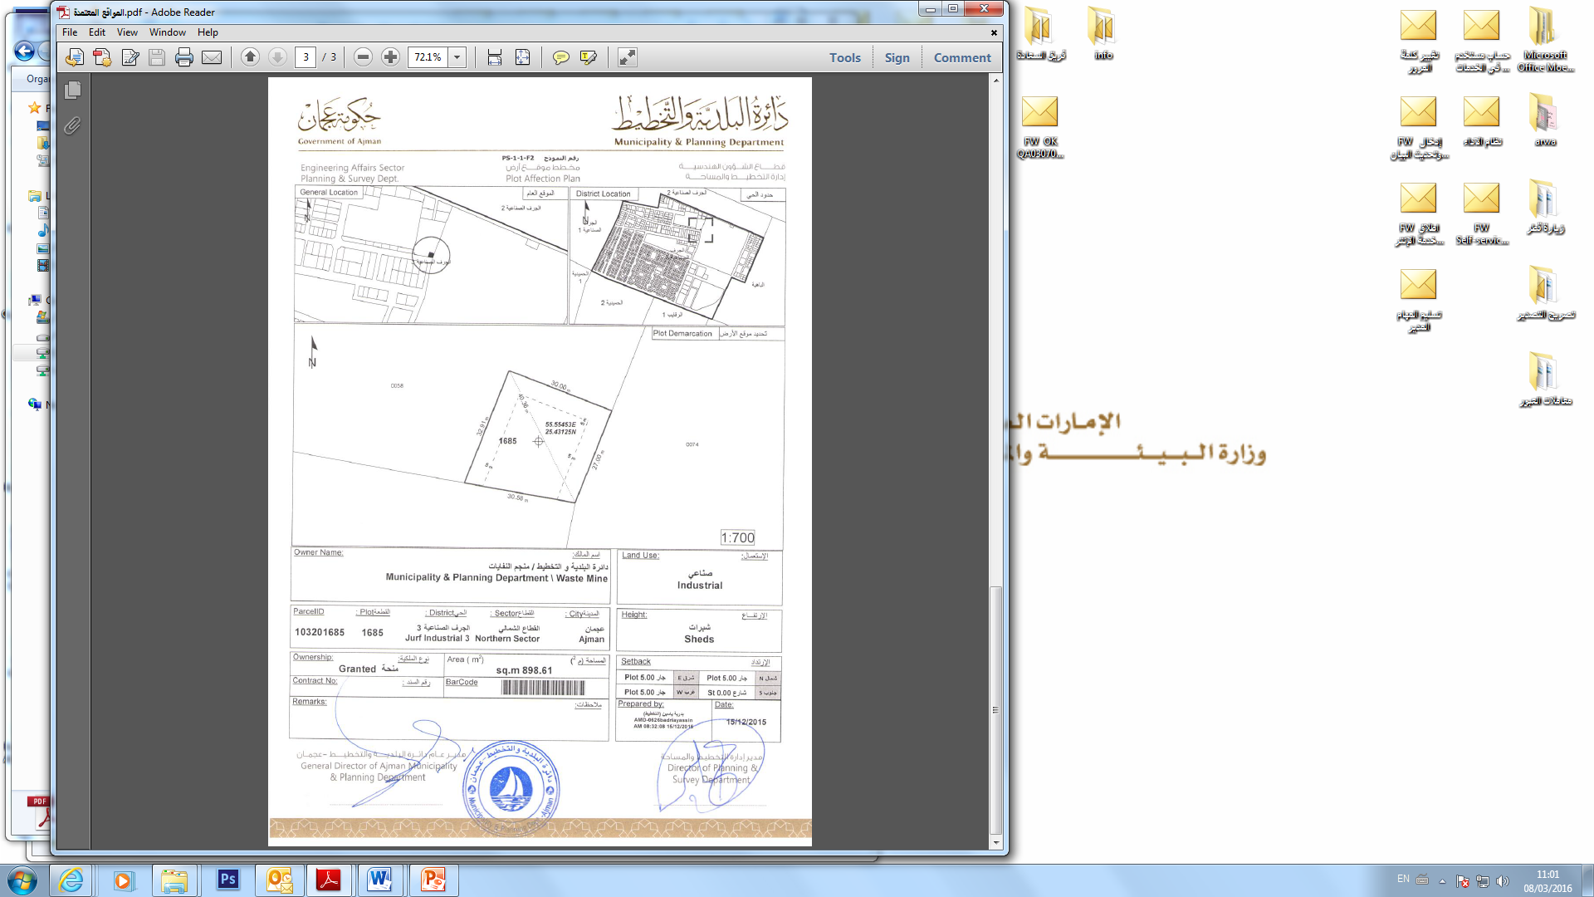**Annex 1 (the proposed land (Aljerf industrial area 3)**

**Annex2 Facility design**

